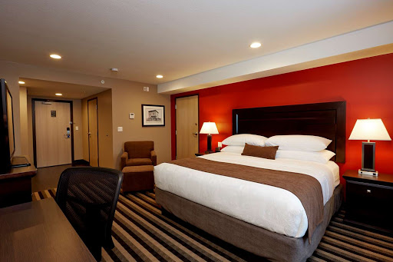

Room for Rent: Spacious, updated 1 bedroom, 1 bathroom apartment room in the Entertainment City of Kingston, available November 30th. Close to the nightlife with a private backyard. $30k per month, with a 15k deposit non-refundable. The building is pet-friendly with heat included. This property is managed by a landlord. Applicants are required to complete rental application. Call Trevor at 222-222-2222

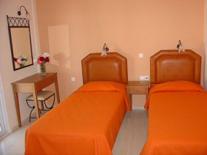

Rental to Students: Spacious, comfortable shared 1 bedroom, with 1 bathroom apartment room in the Cool hills of Cedar Grove Mandeville, available January 1st. Close proximity to NCU $12 per month, with a 12k. This property is managed by a live-in landlord. Contact Stacy at 222-222-2222

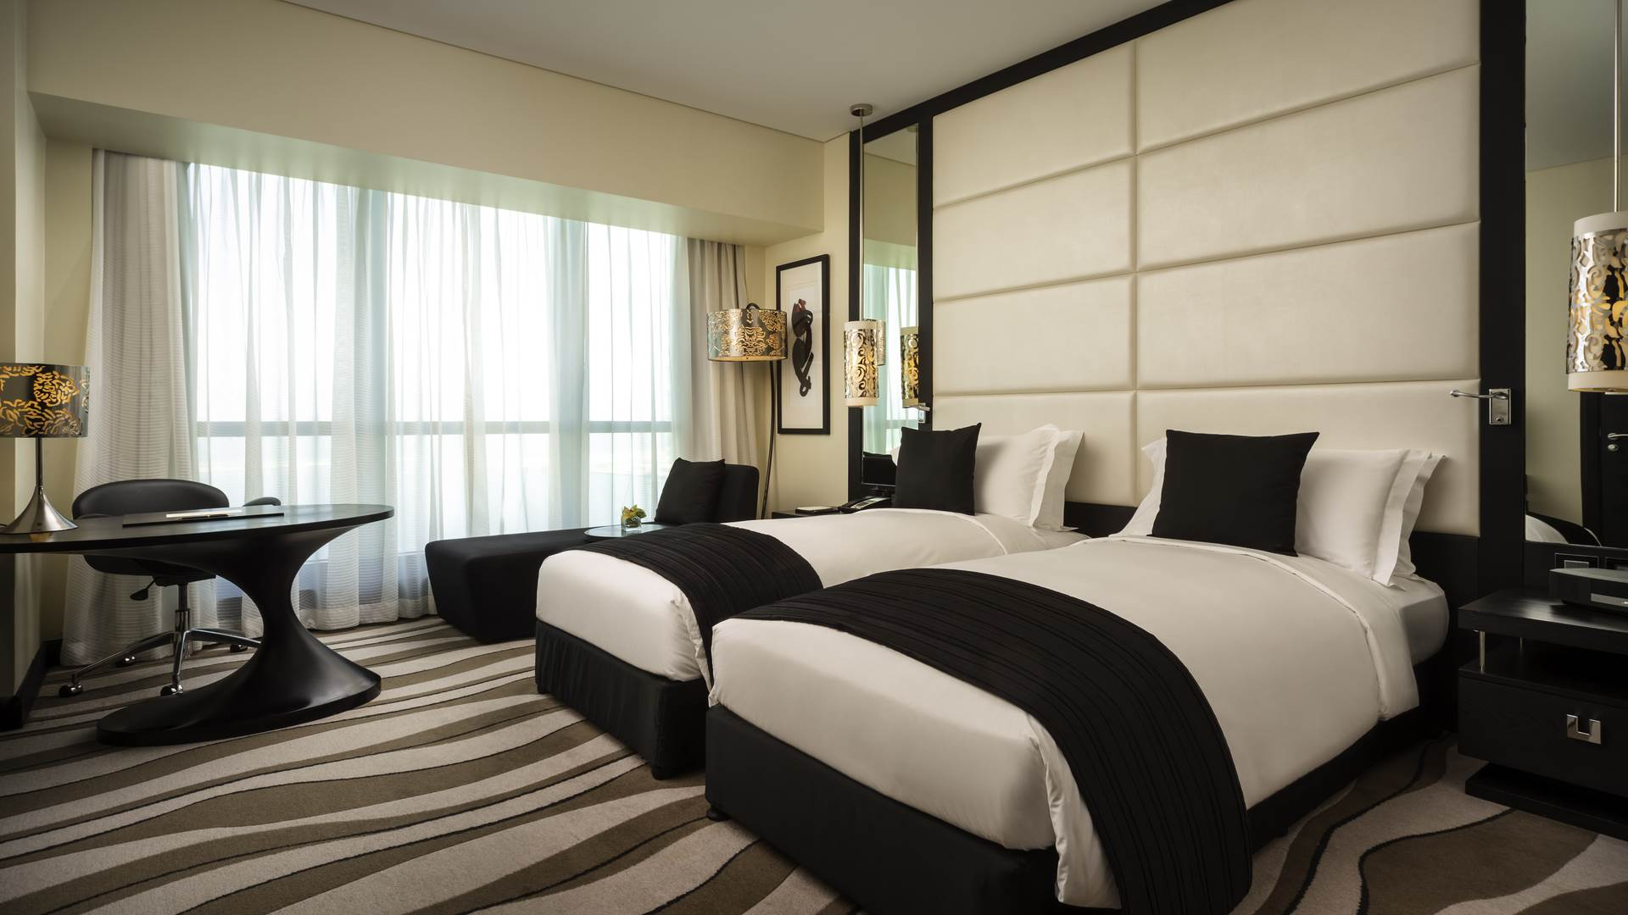

Weekend Get-away: Spacious, and luxurious updated shared 1 bedroom, 1 bathroom apartment room in Florence Hall Trelawney, available only for weekend rental. Close to Falmouth Town and Burwood Beach 20k no deposit required. The building is pet-friendly along with a private pool. This property is managed by a landlord. Call Sam at 222-222-2222

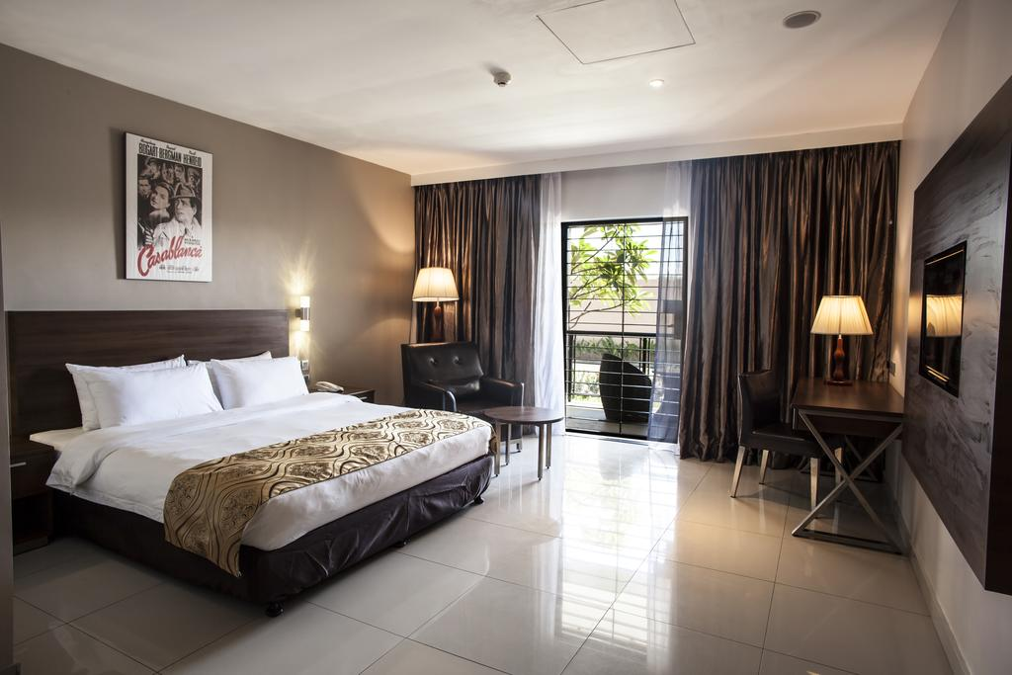

Luxurious Room: Spacious, and luxurious updated shared 1 bedroom, 1 bathroom apartment room in Rose Hall Montego Bay, available for nightly rental. 20 minutes from Montego Bay city and nightly rental of 10k. The building is pet-friendly along with a private pool and private backyard. This property is managed by a landlord. Call Kerry at 222-222-2222

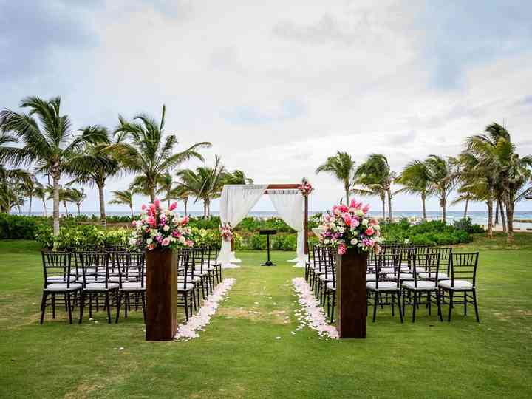

Half Moon is a hotel wedding venue located in Montego Bay, Jamaica. An ideal choice of venue for a diverse range of celebrations, it would suit intimate affairs and grand festivities. This tropical Caribbean setting offers a number of extraordinary spaces - big and small - so, it has ample options. Half Moon Resort provides wedding packages to suit your preferences, while they can arrange activities (golfing, tennis, equestrian) for the newlyweds and their guests to enjoy. Contact Halfmoon services at 33333333 for more info.

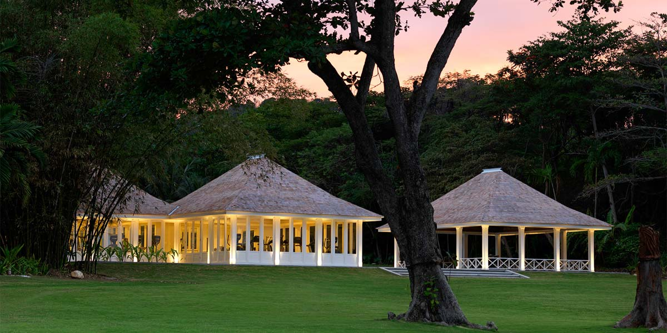

Round Hill: Whether for a business meeting, a private celebration or a destination beach wedding, Round Hill offers breath taking event settings, unparalleled service and the finest in Caribbean hospitality. Discover true island style and subdued sophistication throughout the 36 Ralph Lauren designed oceanfront guestrooms and 27 private, luxury Jamaican villas. Event spaces as well as accommodation across the property are meticulously maintained with remarkable attention to detail. Steeped in rich history, timeless elegance and true understated luxury, Round Hill welcomes guests to all events with genuine Jamaican hospitality while captivating them at every turn. Contact Round hill services at 666666666 for more info.

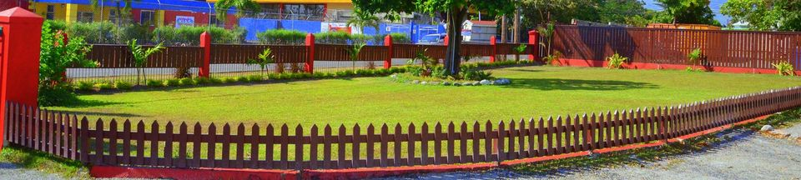

Haining Party Place: Bring your party to us at and we will help you celebrate. We provide decorations and entertainment for your event at request. Contact Sherl at 22222222222

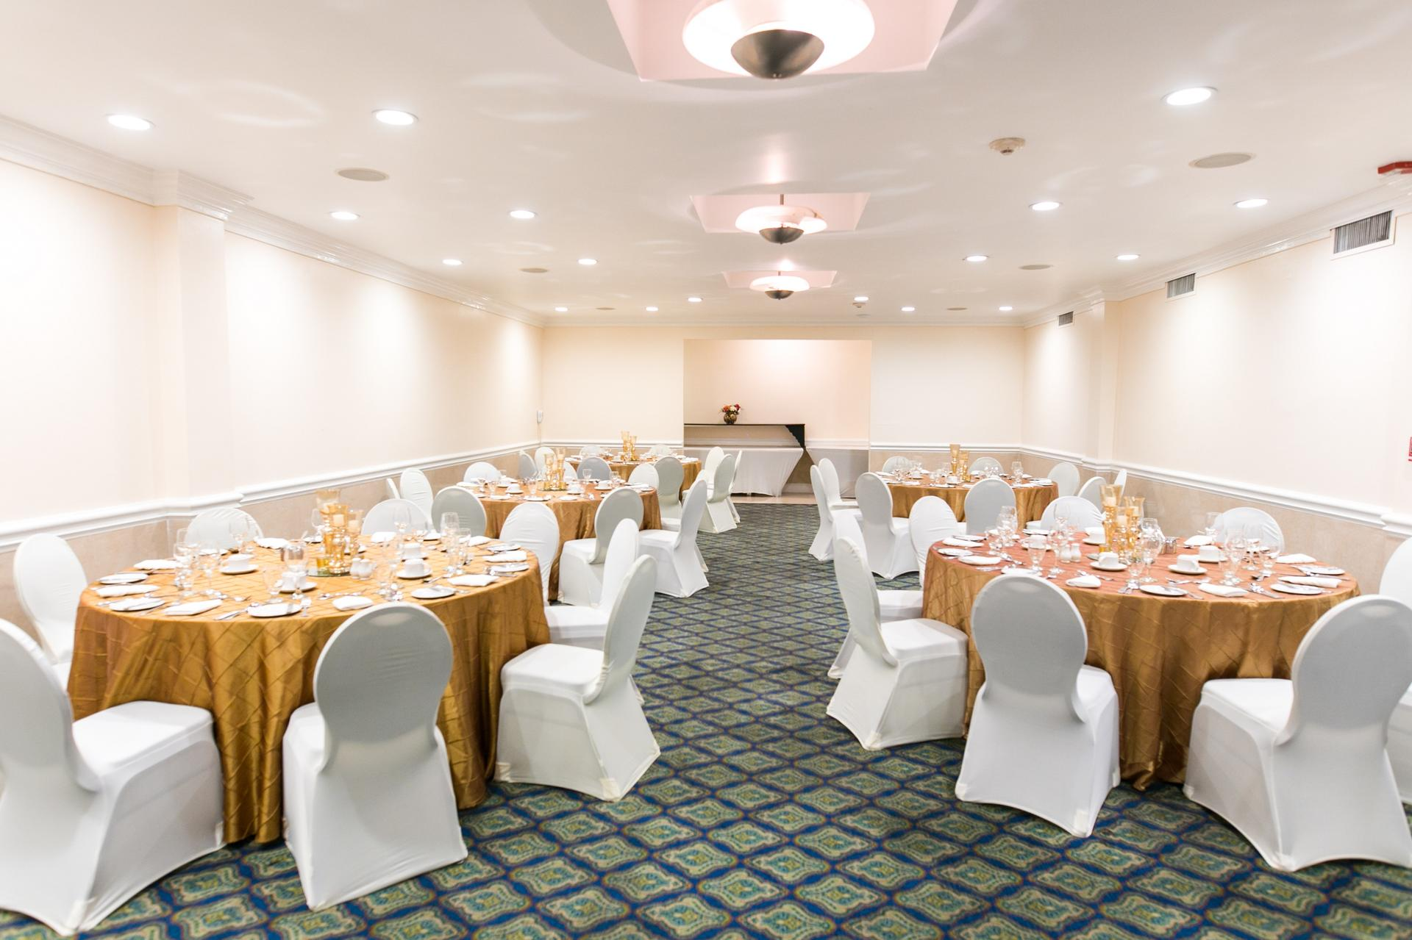

Iberostar Auditorium: Watch magical performances and hold your special occasion or corporate retreat in impressive style at Iberostar Resort & Spa.2,000ft area, with a maximum of 75 seats. 45k for the day. Contact iberostar services at 44444444

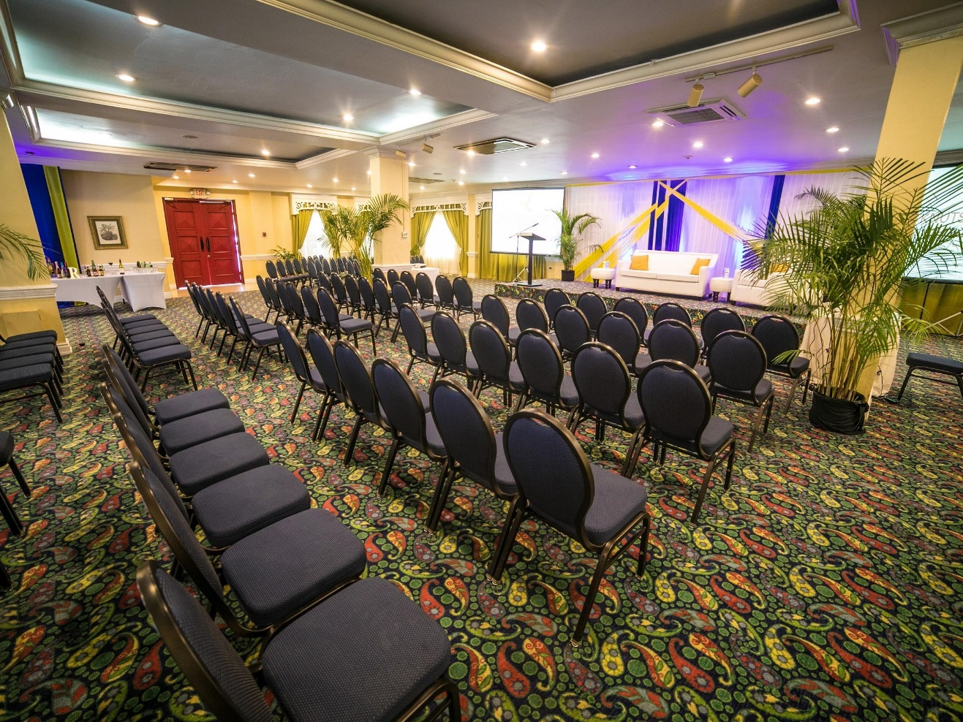

Knutsford Auditorium: Spacious, comfortable and great for entertainment. Book this auditorium for upcoming Business meeting, lectures, Current trends etc. , or your desired event for 30k for the day. Contact Paul at 22222222222

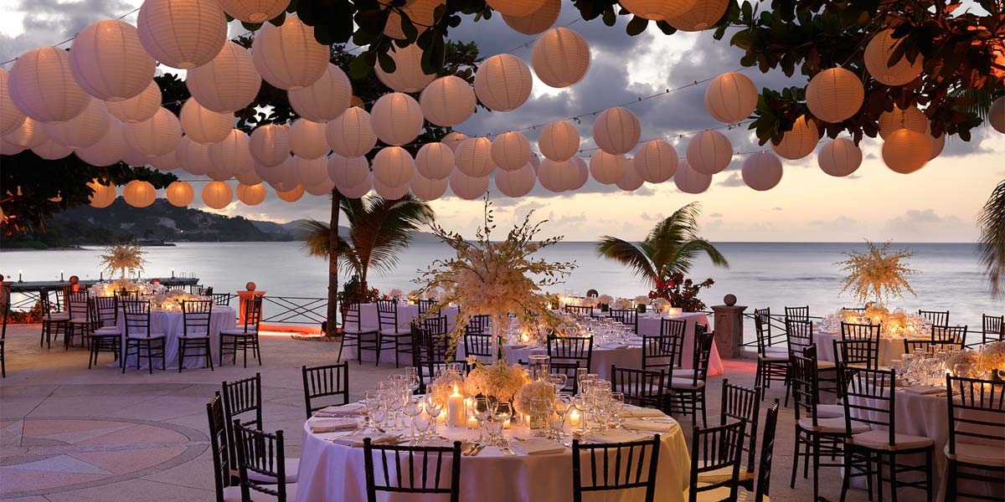

Wedding Dreamers: Make your Wedding perfect with this beautiful cliff and sea view area. Maximum capacity of 50 guests. Catering and Planning services can also be provided. Contact Sher at 5555555555 for more info.

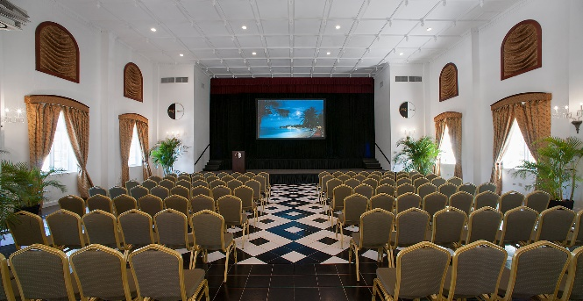

Halfmoon Auditorium: Hold your special occasion or corporate retreat in impressive style at Halfmoon Resort & Spa. Our luxury, all-inclusive resort maintains the traditions and grandeur . Contact Halfmoon services at 444444444.